

Advance Graphics Module for OpenDSS

DSS Visualization Tool - User Manual

Miguel Hernandez

November 2017

License

Copyright © 2017 Electric Power Research Institute, Inc. All rights reserved.

Redistribution and use in source and binary forms, with or without modification, are permitted provided that the following conditions are met:

Redistributions of source code must retain the above copyright notice, this list of conditions and the following disclaimer.

Redistributions in binary form must reproduce the above copyright notice, this list of conditions and the following disclaimer in the documentation and/or other materials provided with the distribution.

Neither the name of the Electric Power Research Institute, Inc., nor the names of its contributors may be used to endorse or promote products derived from this software without specific prior written permission.

THIS SOFTWARE IS PROVIDED BY Electric Power Research Institute, Inc., "AS IS" AND ANY EXPRESS OR IMPLIED WARRANTIES, INCLUDING, BUT NOT LIMITED TO, THE IMPLIED WARRANTIES OF MERCHANTABILITY AND FITNESS FOR A PARTICULAR PURPOSE ARE DISCLAIMED. IN NO EVENT SHALL Electric Power Research Institute, Inc., BE LIABLE FOR ANY DIRECT, INDIRECT, INCIDENTAL, SPECIAL, EXEMPLARY, OR CONSEQUENTIAL DAMAGES (INCLUDING, BUT NOT LIMITED TO, PROCUREMENT OF SUBSTITUTE GOODS OR SERVICES; LOSS OF USE, DATA, OR PROFITS; OR BUSINESS INTERRUPTION) HOWEVER CAUSED AND ON ANY THEORY OF LIABILITY, WHETHER IN CONTRACT, STRICT LIABILITY, OR TORT (INCLUDING NEGLIGENCE OR OTHERWISE) ARISING IN ANY WAY OUT OF THE USE OF THIS SOFTWARE, EVEN IF ADVISED OF THE POSSIBILITY OF SUCH DAMAGE.

NOTE

For further information about EPRI, call the EPRI Customer Assistance Center at 800.313.3774 or   
e-mail askepri@epri.com.

Electric Power Research Institute, EPRI, and TOGETHER…SHAPING THE FUTURE OF ELECTRICITY are registered service marks of the Electric Power Research Institute, Inc.

Copyright © 2017 Electric Power Research Institute, Inc. All rights reserved.

Contents

*1* Introduction 1-1

Components 1-1

Application Cases 1-2

*2* Interface with OpenDSS 2-1

Plot Commands 2-1

Script Example 2-2

*3* Main User Interface 3-1

Interface components 3-1

File Menu 3-2

Figure Menu 3-2

Help Menu 3-4

Figure Synchronization 3-4

*4* Figures 4-1

X-Y Plot 4-1

Interface components 4-1

Interface Functions 4-2

Auto Scale (General tools) 4-2

Select (General tools) 4-2

Pan (General tools) 4-3

X-Zoom (General tools) 4-3

Y-Zoom (General tools) 4-3

Zoom (General tools) 4-3

Export (General tools) 4-3

Copy (General tools) 4-4

Grid (General tools) 4-4

Settings (Auxiliary bar) 4-5

Statistics (Auxiliary bar) 4-6

Voltage Profile 4-6

Interface components 4-7

Interface Functions 4-8

Auto Scale (General tools) 4-8

X-Y Plane (General tools) 4-8

Export (General tools) 4-8

2D (General tools) 4-8

Ph. 1 (General tools) 4-9

Ph. 2 (General tools) 4-9

Ph. 3 (General tools) 4-9

Limits (General tools) 4-9

Grid (General tools) 4-9

Primary (Auxiliary bar) 4-9

Secondary (Auxiliary bar) 4-9

3D Navigation 4-10

Matrix Plot 4-10

Interface components 4-10

Interface Functions 4-11

Auto Scale (General tools) 4-11

Select (General tools) 4-11

Pan (General tools) 4-12

X-Zoom (General tools) 4-12

Y-Zoom (General tools) 4-12

Zoom (General tools) 4-12

Export (General tools) 4-12

Copy (General tools) 4-13

Grid (General tools) 4-13

Search (Auxiliary bar) 4-14

3D Navigation 4-15

Scatter Plot 4-15

Interface components 4-16

Interface Functions 4-18

Auto Scale (General tools) 4-18

Select (General tools) 4-18

Pan (General tools) 4-19

X-Zoom (General tools) 4-19

Y-Zoom (General tools) 4-19

Zoom (General tools) 4-19

Export (General tools) 4-19

Grid (General tools) 4-19

Coordinates (General tools) 4-20

Settings (Auxiliary bar) 4-20

Search (Auxiliary bar) 4-21

3D Navigation 4-23

Density Evolution Plot 4-23

Interface components 4-24

Interface Functions 4-25

Auto Scale (General tools) 4-25

Select (General tools) 4-25

Export (General tools) 4-26

Plot PDF/CDF (General tools) 4-26

PDF (General tools) 4-27

CDF (General tools) 4-28

Invert X, Y axes (General tools) 4-28

Contours (General tools) 4-28

Limits (General tools) 4-28

Settings (Auxiliary bar) 4-28

Search (Auxiliary bar) 4-29

3D Navigation 4-30

*5* Communication Protocol 5-1

*6* Document Version History 6-1

*7* References 7-1

List of Figures

Figure 1‑1 The conceptual structure of the DSS Visualization Tool. 1-1

Figure 1‑2 Internal components of the visualization tool. 1-2

Figure 1‑3 Use case from the internal perspective. 1-2

Figure 1‑4 Application scenario: Single-machine simulation. 1-3

Figure 1‑5 Application scenario: multi-machine simulation. 1-3

Figure 3‑1 Main user interface. 3-1

Figure 3‑2 File menu options. 3-2

Figure 3‑3 Figure menu options. 3-3

Figure 3‑4 Help menu options. 3-4

Figure 3‑5 Example of figure groups on the main interface window. 3-5

Figure 3‑6 Example of synchronized cursors. 3-5

Figure 4‑1 X-Y plot interface. 4-1

Figure 4‑2 Cursor navigation mode on an X-Y plot. 4-3

Figure 4‑3 Export dialog for X-Y plot interface. 4-4

Figure 4‑4 Copy figure dialog for X-Y plot interface. 4-4

Figure 4‑5 Chart settings dialog for X-Y plot interface (Axis). 4-5

Figure 4‑6 Chart settings dialog for X-Y plot interface (Normalization). 4-5

Figure 4‑7 Statistics dialog for X-Y plot interface. 4-6

Figure 4‑8 Voltage profile interface. 4-7

Figure 4‑9 Export dialog on voltage profile interface. 4-8

Figure 4‑10 Two-dimensional view of the voltage profile. 4-9

Figure 4‑11 Admittance matrix interface. 4-10

Figure 4‑12 Cursor navigation mode on admittance matrix interface. 4-12

Figure 4‑13 Export dialog for admittance matrix interface. 4-13

Figure 4‑14 Copy dialog for admittance matrix interface. 4-13

Figure 4‑15 Search dialog on matrix plot interface. 4-14

Figure 4‑16 Example for set cursor function on matrix plot. 4-15

Figure 4‑17 Scatter plot interface. 4-16

Figure 4‑18 Cursor navigation mode on scatter plot. 4-18

Figure 4‑19 The export dialog of the scatter plot interface. 4-19

Figure 4‑20 Chart settings dialog for scatter plot interface (Data). 4-20

Figure 4‑21 Chart settings dialog for scatter plot interface (Labels and normalization). 4-21

Figure 4‑22 Search dialog on scatter plot interface. 4-22

Figure 4‑23 Example for set cursor function on scatter plot. 4-22

Figure 4‑24 Density evolution plot interface. 4-23

Figure 4‑25 Cursor navigation mode on density evolution plot. 4-26

Figure 4‑26 Export dialog for density evolution interface. 4-26

Figure 4‑27 Example for plot PDF/CDF functions. 4-27

Figure 4‑28 Example of the probability density function view. 4-27

Figure 4‑29 Example of the cumulative density function view. 4-28

Figure 4‑30 Settings dialog for density evolution interface. 4-29

Figure 4‑31 Search dialog on density evolution plot. 4-29

Figure 4‑32 Example of plotted monitors from density evolution interface. 4-30

# Introduction

The advanced visualization tool (DSS Visualization Tool) was designed to enhance the visualization of distribution system simulations with a flexible, scalable and meaningful approach. The application runs with 64-bit architecture on Microsoft Windows 7 or posterior versions. This tool is capable of plotting multiple electrical variables obtained from the OpenDSS simulator and was programmed based on the actor framework approach to achieve an efficient management of concurrent tasks and convenient scalability. Figure 1‑1 shows the conceptual structure of the visualization tool in connection with the OpenDSS simulator. The executable application is composed of a network management core, a visualization manager, and multiple charts to visualize data. The network manager is implemented as a TCP/IP client with multi-terminal capabilities for flexible communication in single-machine or multi-machine applications. The visualization manager includes the main user interface for efficient management of multiple graphical resources, and the charts are implemented as five classes of visualization actors that can be generated and simultaneously manipulated. The graphical features of this visualization tool are intended to improve the experience of comprehensive analysis for electrical distribution systems based on simulation results.

C:\Users\pmhe007\Desktop\0.emf

Figure ‑  
The conceptual structure of the DSS Visualization Tool.

Components

The visualization tool was implemented with seven actors that can be dynamically generated and cloned at running time. As can be seen in Figure 1‑2, the data communication is implemented by TCP/IP protocol and handled by an actor to communicate simulation results to the TCP server inside the main actor. The main actor includes a set of functions that allow users to generate and manipulate figures (chart manager), and communication sockets by demand (TCP Server). The remaining actors were implemented to execute specific visualization functions in five categories: X-Y plots, voltage profiles, matrix plots, scatter plots, and density evolution plots. Please refer to the Figures section (chapter 4) for detailed information regarding each category.

C:\Users\pmhe007\Desktop\Block diagram 1.emf

Figure ‑  
Internal components of the visualization tool.

As can be seen in the example in Figure 1‑3, the internal components are designed to generate clones of the desired actor by demand. These actions are performed as a response to TCP/IP messages or user interface interactions, as described in this document. The example in Figure 1‑3 shows that the application can be used to visualize multiple figures from different clients at the same time.

C:\Users\pmhe007\Desktop\Block diagram 2.emf

Figure ‑  
Use case from the internal perspective.

Application Cases

The multi-client capability of this application can be exploited to connect multiple simulation cases running on the same machine, as shown in Figure 1‑4. In this way the visualization will be useful to analyze, compare, and validate between multiple operational cases or simulation models. Users are encouraged to take advantage of the figure synchronization capability, described in chapter 3, for convenient navigation between scenarios.

C:\Users\pmhe007\Desktop\2.emf

Figure ‑4  
Application scenario: Single-machine simulation.

The application allows the user to visualize data in a multi-machine setup (Figure 1‑5), because of the flexibility of the multi-client approach. In this way, users can analyze data from multiple machines/platforms with minimum setup. It is only required for a simulation client to have network access to the visualization server and communicate with a valid IP address.

C:\Users\pmhe007\Desktop\3.emf

Figure ‑5  
Application scenario: multi-machine simulation.

# Interface with OpenDSS

The DSS Visualization Tool has been primarily designed for taking advantage of the electrical results obtained from the Open Distribution System Simulator™. To achieve a close integration with the simulator, the OpenDSS plot command has been enhanced to include the data communication protocol and to facilitate the visualization experience. At the current status, the communication routines are configured to communicate on a single machine setup with the local IP address. Therefore, it is required to install the DSS Visualization Tool on the same machine in which the OpenDSS is installed. Users would be able to use the DSSVisualizationTool option to enable the enhanced version of the plot command on the OpenDSS environment. The following commands illustrate the use of this option.

|  |  |
| --- | --- |
| Set DSSVisualizationTool = true | The plot command is enabled to use additional options to send data to the DSS Visualization Tool. New plot modes are enabled with this option enabled. Only unsupported figures will be plotted with the DSSView application. |
| Set DSSVisualizationTool = false | The plot command is restricted to use the DSSView application. |

Plot Commands

The following includes a list of the plot options that can be used with the DSS Visualization Tool (the user is encouraged to consult the OpenDSS reference guide for further details):

|  |  |
| --- | --- |
| plot monitor object=monitorname | Generates an X-Y plot with the content of the desired monitor designated with the object property. Other plot properties are ignored. All channels are included in this plot. Please refer to section 4 for further details regarding the X-Y plot. |
| plot loadshape object=lshapename | Generates an X-Y plot with the content of the desired loadshape designated with the object property. Other plot properties are ignored. In case of loadshapes with active and reactive multipliers, both sets of data are included. Please refer to section 4 for further details regarding the X-Y plot. |
| plot profile | Generates a voltage profile plot with the line-to-ground magnitude of all bus voltages in per unit base, please referrer to the OpenDSS reference guide for further information. Other plot properties are ignored. This command is equivalent to the option phases=all on the base version of the plot profile command. Please refer to section 4 for further details regarding the voltage profile plot. |
| plot matrix | Generates a matrix plot with the content of the incidence matrix which describes the circuit connectivity. This figure requires a previous calculation of the incidence matrix; please referrer to the OpenDSS reference guide for further information. Other plot properties are ignored. Please refer to section 4 for further details regarding the matrix plot. |
| plot scatter | Generates a scatter plot with the line-to-ground magnitude of bus voltages in per unit base. Only buses with defined geographical coordinates are included. Other requirements for this figure are similar to the ones related to the plot profile command; please referrer to the OpenDSS reference guide for further information. Voltage magnitudes include results for nodes 1, 2 and 3. Other plot properties are ignored. Please refer to section 4 for further details regarding the scatter plot. |
| plot evolution | Generates a density evolution plot with the line-to-ground magnitude of all load voltages in per unit base. This command automatically executes four steps in the simulator. First, it installs monitors on every defined load. Next, it executes the solve command to perform a time-domain simulation. Then, it collects all the data from the monitors attached to the load, and finally, it communicates the data to the DSS Visualization Tool. Other plot properties are ignored. The execution of this command generates a succinct overview of the circuit performance based on statistical analysis. Please refer to section 4 for further details regarding the density evolution plot. |

Script Example

The following script shows an example to perform a series of simulations and to communicate the results to the DSS Visualization Tool. This script should be saved in the directory designated to store the ckt24 test circuit on the OpenDSS installation directory (Typically C:\Program Files\OpenDSS\EPRITestCircuits\ckt24).

|  |
| --- |
| Clear  redirect (master_ckt24.dss) // Ckt24 model  // - Incidence matrix visualization - //  set DSSVisualizationTool=true ! DSS Visualization tool enabled  CalcIncMatrix ! Incidence matrix calculation  plot matrix ! Incidence matrix plot  CalcIncMatrix_O ! Ordered version of the incidence matrix  plot matrix ! Incidence matrix plot  // - Snapshot solution and visualization - //  set mode=snapshot Loadmult=1 ! Peak load condition  solve  set DSSVisualizationTool=true ! DSS Visualization tool enabled  plot profile ! Voltage profile  plot scatter ! Scatter plot  set mode=snapshot Loadmult=0.7 ! 70% load condition  solve  plot profile ! Voltage profile  plot scatter ! Scatter plot  // - Time sequential solution and visualization - //  set DSSVisualizationTool=true ! DSS Visualization tool enabled  plot loadshape object=ls_threephase  Set mode=yearly stepsize=1h number=168 ! one week simulation  set controlmode=static // Default control mode  set hour=8256  plot evolution ! Solve command is included in the density evolution plot  plot monitor object=fdr_05410_mon_pq  // - Time sequential solution and visualization - //  redirect (master_ckt24.dss) // Ckt24 model  set DSSVisualizationTool=true ! DSS Visualization tool enabled  Set mode=yearly stepsize=1h number=168 ! one week simulation  set controlmode=off // Control disabled  set hour=8256  plot evolution ! Solve command is included in the density evolution plot  plot monitor object=fdr_05410_mon_pq |

# Main User Interface

The main interface was designed for efficient management of multiple figures and to facilitate the data analysis process. This interface can be used to load/save DS Visualization format files, modify global properties of figures, and manipulate groups to achieve figure synchronization. The user interface is composed of two areas, as shown in Figure 3‑1.

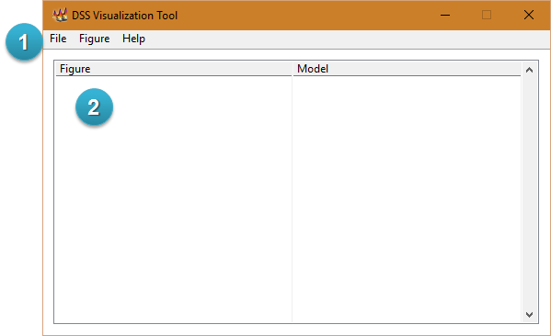

Figure ‑  
Main user interface.

Interface components

The main components of the user interface are described below. Numbers inside parenthesis refer to circled numbers on Figure 3‑1.

|  |  |
| --- | --- |
| Menu (1) | This area has multiple menu options for data and figure management. Please refer to the corresponding menu section for additional information. |
| Figure list (2) | This area shows a list of figures on execution. Each new figure is included in the list with a figure name and the corresponding model name. Single or multiple selections are available as an argument for certain menu functions. Please refer to the corresponding menu section for additional information. Drag and drop of single or multiple entries is allowed for the assignment of figure groups. When a group is created the figure members are associated by means of a system tree view. Multiple groups can be simultaneously managed. |

File Menu

The file functions can be accessed by the menu option highlighted with the number 1 on Figure 3‑2 or by the corresponding keyboard shortcuts.

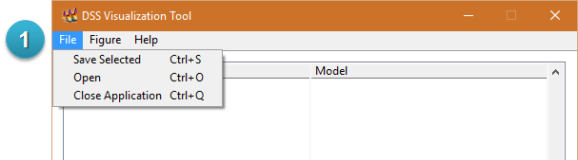

Figure ‑  
File menu options.

|  |  |
| --- | --- |
| Save selected | Shortcut: Ctrl+S  This function creates a data file associated with a certain figure for future use. Single or multiple figures can be selected as an argument for this function. The data file is saved in binary form with the DS Visualization format (.dsviz). The default file name is composed of the figure name and time stamp for convenience. |
| Open | Shortcut: Ctrl+O  This function loads a data file associated with a certain figure to generate the corresponding visualization. Single or multiple files can be selected as an argument for this function. The data file is loaded from the binary form with the DS Visualization format (.dsviz). |
| Close Application | Shortcut: Ctrl+Q  This function closes all the figures on execution and exits the main interface. |

Figure Menu

The figure functions can be accessed by the menu option highlighted with the number 1 on Figure 3‑3 or by the corresponding keyboard shortcuts.

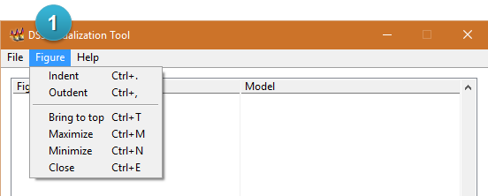

Figure ‑  
Figure menu options.

|  |  |
| --- | --- |
| Indent | Shortcut: Ctrl+.  This function includes the selection as part of a new figure group starting from the figure on the top. Single or multiple figures can be selected as an argument for this function. If the selection is already part of a group, the function has no effect. |
| Outdent | Shortcut: Ctrl+,  This function removes the selection from a figure group. Single or multiple figures can be selected as an argument for this function. If the selection is not part of any group, the function has no effect. |
| Bring to top | Shortcut: Ctrl+T  This function opens the window corresponding to the selection (on top of other windows). Single or multiple figures can be selected as an argument for this function. |
| Maximize | Shortcut: Ctrl+M  This function maximizes the window corresponding to the selection. Single or multiple figures can be selected as an argument for this function. |
| Minimize | Shortcut: Ctrl+N  This function minimizes the window corresponding to the selection. Single or multiple figures can be selected as an argument for this function. |
| Close | Shortcut: Ctrl+E  This function closes the window corresponding to the selection. Single or multiple figures can be selected as an argument for this function. |

Help Menu

The help menu can be accessed by the option highlighted with the number 1 on Figure 3‑4 or by the corresponding keyboard shortcuts.

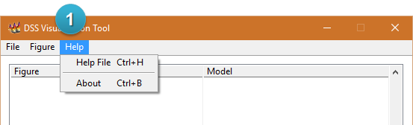

Figure ‑  
Help menu options.

|  |  |
| --- | --- |
| Help file | Shortcut: Ctrl+H  This option opens the documentation file (PDF). |
| About | Shortcut: Ctrl+B  This window shows details regarding, license, software version, and the Internet Protocol address of the machine in which the visualization tool is running. |

Figure Synchronization

The main user interface has a synchronization feature to facilitate the analysis of multiple simulation results. This feature uses the concept of figure groups to associate the cursor position between multiple windows. In this way, the user can simultaneously plot multiple electrical variables and navigate between them to observe multiple phenomena. As the source of cursor synchronization is the time domain, this feature should be used with data provided by time-sequential simulations. Figure 3‑5 shows an example of three figure groups created by means of the indent function (please refer to the figure menu section for further information) or the drag and drop action with the mouse. The group membership starts with the figure identified with a collapse icon on the tree view and ends with the last figure indented under this level. Each figure group member is automatically synchronized to obtain the same time domain location for the cursor navigation with other members of the group. Multiple groups can be created to achieve independent synchronization between simulation scenarios, circuit models, or other classifications of interest. To stop the cursor synchronization for certain figure, the user can use the outdent function (please refer to the figure menu section for further information).

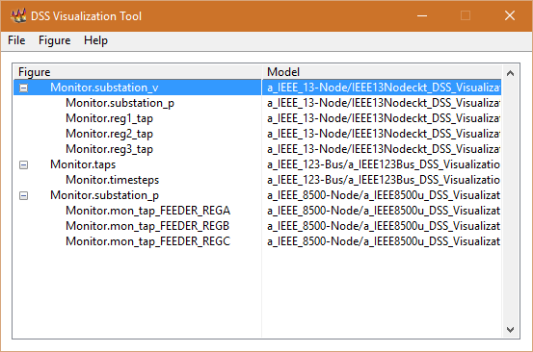

Figure ‑  
Example of figure groups on the main interface window.

As shown in Figure 3‑6 the cursor location for members of the group contained on the main interface (highlighted with the number 1) is synchronized. When the user enables the cursor navigation mode on any of the group members (highlighted with the numbers 2, 3, 4, 5, and 6) and changes the x-axis cursor location, other members change the cursor location to highlight data that was recorded at the same time step.

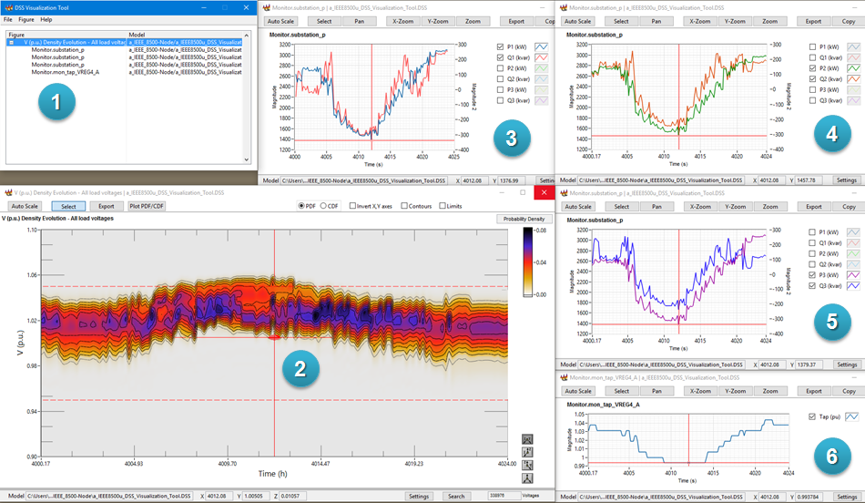

Figure ‑  
Example of synchronized cursors.

# Figures

X-Y Plot

The X-Y plot interface was designed to plot and navigate with continuous or discontinuous data from multiple sources. This interface can be used to generate figures from data recorded by monitors, voltage profiles, or load profiles. The user interface is composed of four areas, as shown in Figure 4‑1.

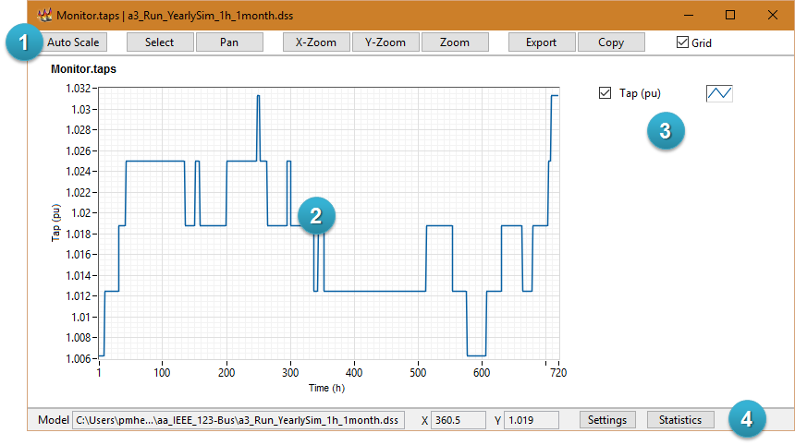

Figure ‑  
X-Y plot interface.

Interface components

The main components of the user interface are described below. Numbers inside parenthesis refer to circled numbers on Figure 4‑1.

|  |  |
| --- | --- |
| General Tools (1) | This area has buttons to trigger interface functions or provide quick customization to the figure. Please refer to the Interface Functions section for additional information. |
| Plot area (2) | This area shows the two-dimensional representation of the data in Cartesian coordinates. The axes limits can be customized by double-clicking the numbers on the limit to introduce a new numerical value. |
| Plot palette (3) | This area shows a list of plots included on the X-Y plot interface. Each entry on the list can be enabled or disabled for graphical visualization of the plot area by clicking on the selection box at the left. Further customization options (colors, interpolation style, etc.) can be found by clicking on the figure icon on the right. Users are encouraged to explore the multiple options on this customization menu. |
| Auxiliary bar (4) | This area shows complementary information and additional customization functions.   * Model: Directory path to the DSS file used to generate the figure. * X: Current value of the horizontal axis at the cursor location. This value is dynamically updated when the cursor location changes. * Y: Current value of the vertical axis at the cursor location. This value is dynamically updated when the cursor location changes. |

Interface Functions

The following are descriptions of each function on the user interface.

Auto Scale (General tools)

This button triggers an automatic adjustment of the vertical and horizontal axis on the figure. It is useful to restore the initial appearance of the figure after zooming or navigating.

Select (General tools)

This button enables the cursor navigation mode shown in Figure 4‑2. The cursor is shown as a red mark with horizontal and vertical projections. As can be seen in Figure 4‑2, the current cursor location is highlighted with the number 1, and the cursor coordinates are highlighted with the number 2. The user can drag the cursor location with a click and hold on the central point of the cursor. It is also possible to move the cursor location by dragging the horizontal or vertical projections lines (red lines).

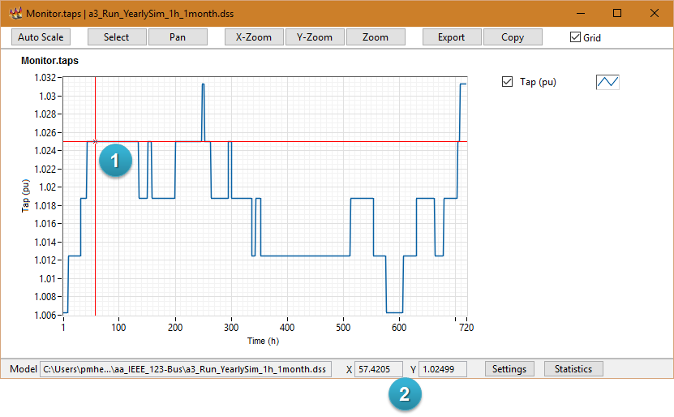

Figure ‑  
Cursor navigation mode on an X-Y plot.

Pan (General tools)

This function enables the panning tool. The user can use this tool to navigate by means of click and dragging the content of the plot area.

X-Zoom (General tools)

This function enables the horizontal zooming tool. The user can use this tool to navigate by means of click and holding to delimitate the area of interest.

Y-Zoom (General tools)

This function enables the vertical zooming tool. The user can use this tool to navigate by means of click and holding to delimitate the area of interest.

Zoom (General tools)

This function enables the rectangular zooming tool. The user can use this tool to navigate by means of click and holding to delimitate the area of interest.

Export (General tools)

This button triggers a dialog window with export options as shown in Figure 4‑3. The dialog allows the user to enable/disable the grid, generate graphics output files (BMP, EPS, EMF), or exporting the data to a new Excel file. Multiple options can be selected on this dialog. Microsoft Excel is required to export the data to an Excel file.

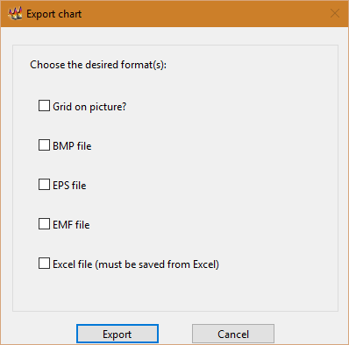

Figure ‑  
Export dialog for X-Y plot interface.

Copy (General tools)

This button triggers a dialog window with copy options as shown in Figure 4‑4. The dialog allows the user to enable/disable the grid, and copy graphics output files (BMP, EPS, EMF) to the clipboard. Only one file format can be selected on this dialog.

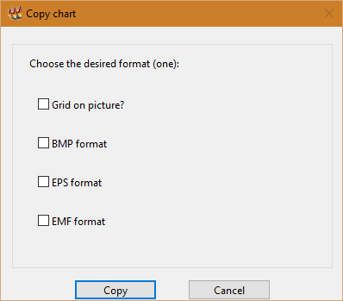

Figure ‑  
Copy figure dialog for X-Y plot interface.

Grid (General tools)

This option can be used to enable/disable the grid in the plot area.

Settings (Auxiliary bar)

This button triggers a dialog window with settings options as shown in Figure 4‑5 and Figure 4‑6. As can be seen in Figure 4‑5, the axis dialog shows the chart name (highlighted with the number 1), and it also allows the user to choose between single-axis or dual-axis mode (highlighted with the number 2). The vertical axes labels can be customized with the string controls highlighted with the number 3. Numbers 4 and 5 highlight the list of plots associated with each vertical axis in the dual-axis mode. Buttons highlighted by the number 6 can be used to change associations of selected plots between axes.

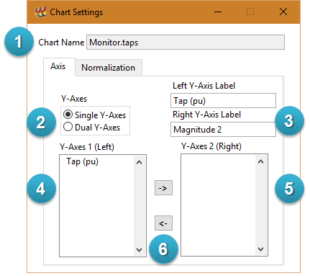

Figure ‑  
Chart settings dialog for X-Y plot interface (Axis).

As can be seen in Figure 4‑6, the normalization dialog includes two areas to customize the vertical and horizontal multipliers. The vertical axes base values can be adjusted with the numeric controls highlighted with the number 1. The horizontal axis base value and label can be adjusted with the controls highlighted with the number 2. This normalization function can be used to obtain *per unit* values on the vertical axes, and it can be also used to change the time scale of the figure (changes between seconds, minutes, days, etc.).

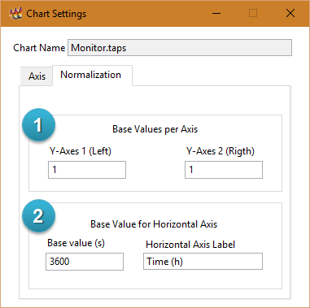

Figure ‑  
Chart settings dialog for X-Y plot interface (Normalization).

Statistics (Auxiliary bar)

This button triggers a dialog window with a summary of descriptive statistics obtained from the plots, as shown in Figure 4‑7. In this dialog the user can find the calculated value for the following variables:

* Mean: Calculates the arithmetic mean, or average, of the values in each plot.
* Standard deviation: Calculates the standard deviation of the values in each plot.
* Variance: Calculates the calculated variance of the values in each plot.
* Median: Finds the median value in each plot. The function sorts the values in each plot and selects the middle element of the sorted values.
* Mode: Finds the value that occurs most often in the values in each plot.
* Range: Finds the value of the range from the lowest point to the highest point in a set of values in each plot.
* Maximum value: Finds the highest point in a set of values in each plot.
* Time of maximum value: Finds the time of the highest point in a set of values in each plot.
* Minimum value: Finds the lowest point in a set of values in each plot.
* Time of minimum value: Finds the time of the lowest point in a set of values in each plot.
* Samples: Total number of samples in each plot.
* Time delta: Time between samples in each plot.

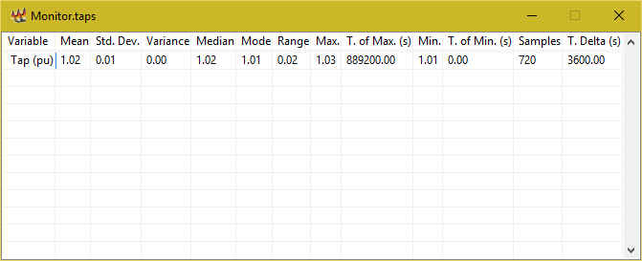

Figure ‑  
Statistics dialog for X-Y plot interface.

Voltage Profile

The voltage profile plot interface was designed to plot and navigate in a three-dimensional version of the voltage profile. This interface can be used to generate figures from the plot profile command on OpenDSS, please referrer to the OpenDSS Manual for further information. The user interface is composed of three areas, as shown in Figure 4‑8.

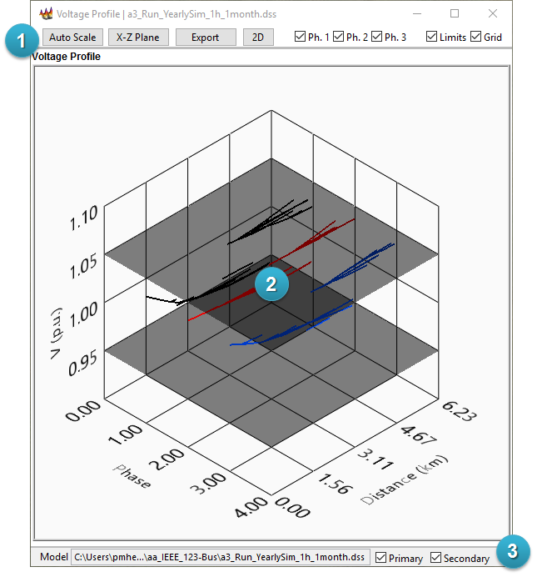

Figure ‑  
Voltage profile interface.

Interface components

The main components of the user interface are described below. Numbers inside parenthesis refer to circled numbers on Figure 4‑8.

|  |  |
| --- | --- |
| General Tools (1) | This area has buttons to trigger interface functions or provide quick customization to the figure. Please refer to the Interface Functions section for additional information. |
| Plot area (2) | This area shows the three-dimensional representation of the voltage profile in Cartesian coordinates. Further customization options (colors, cursors, axis limits, etc.) can be found by right-clicking on the figure and selecting the 3D Graph Properties option. Users are encouraged to explore the multiple options on this customization menu. Please refer to the 3D navigation section for further information about zooming and panning. |
| Auxiliary bar (4) | This area shows complementary information and additional customization functions.   * Model: Directory path to the DSS file used to generate the figure. |

Interface Functions

The following are descriptions of each function on the user interface.

Auto Scale (General tools)

This button triggers an automatic adjustment of the vertical and horizontal axis on the figure. It is useful to restore the initial appearance of the figure after zooming or navigating.

X-Y Plane (General tools)

This button triggers the adjustment of the three-dimensional figure to obtain the perspective from the X-Z plane.

Export (General tools)

This button triggers a dialog window with export options as shown in Figure 4‑9. The dialog allows the user to generate graphics output files (BMP, JPEG, PNG). Multiple options can be selected on this dialog.

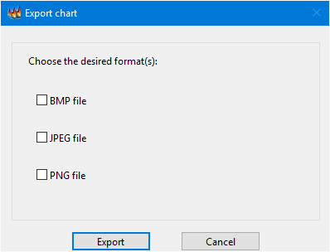

Figure ‑  
Export dialog on voltage profile interface.

2D (General tools)

This button generates an X-Y plot with the two-dimensional representation of the data, as shown in Figure 4‑10. Please refer to the X-Y Plot figure description for further information.

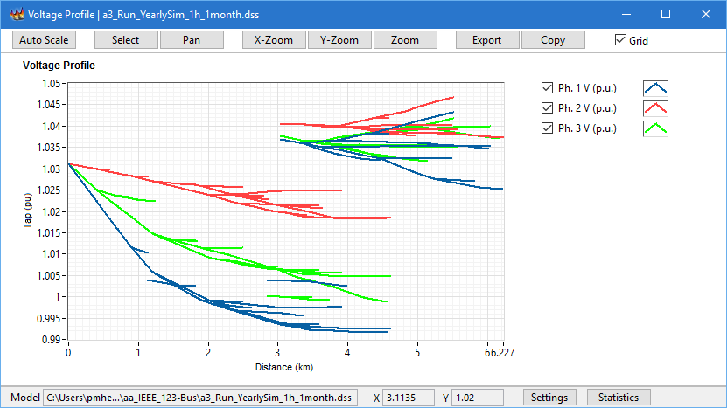

Figure ‑  
Two-dimensional view of the voltage profile.

Ph. 1 (General tools)

This option can be used to enable/disable the first phase on the plot area.

Ph. 2 (General tools)

This option can be used to enable/disable the second phase on the plot area.

Ph. 3 (General tools)

This option can be used to enable/disable the third phase on the plot area.

Limits (General tools)

This option can be used to enable/disable the voltage limits represented by a couple of X-Y planes (0.95 Vpu and 1.05 Vpu by default). The voltage limits can be customized from the 3D Graph Properties option as described in the interface components section.

Grid (General tools)

This option can be used to enable/disable the grid in the plot area.

Primary (Auxiliary bar)

This option can be used to enable/disable primary lines on the plot area (voltage level > 1kV).

Secondary (Auxiliary bar)

This option can be used to enable/disable secondary lines on the plot area (voltage level < 1kV).

3D Navigation

The three-dimensional plot can be navigated by clicking inside the 3D Graph container and using the mouse to change the view. To rotate the graph, click and drag the mouse across the graph container. To pan across the graph, press and hold the control key, then click and drag the mouse. To zoom in or out on the graph, press and hold the shift key, then click and drag the mouse.

Matrix Plot

The matrix plot interface was designed to plot and navigate in the two-dimensional and three-dimensional representations of the incidence matrix of the model. This interface can be used to analyze the simulation model at a mathematical level. The user interface is composed of four areas, as shown in Figure 4‑11.

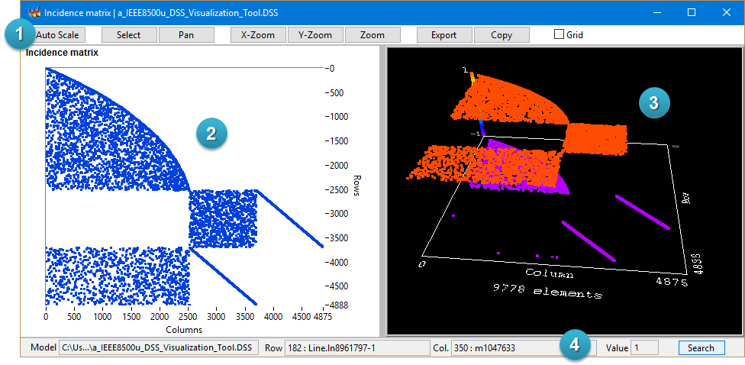

Figure ‑  
Admittance matrix interface.

Interface components

The main components of the user interface are described below. Numbers inside parenthesis refer to circled numbers on Figure 4‑11.

|  |  |
| --- | --- |
| General Tools (1) | This area has buttons to trigger interface functions or provide quick customization to the figure. Please refer to the Interface Functions section for additional information. |
| 2D Plot area (2) | This area shows the two-dimensional representation of the data in Cartesian coordinates. The axes limits can be customized by double-clicking the numbers on the limit to introduce a new numerical value. |
| 3D Plot area (3) | This area shows the three-dimensional representation of the data in Cartesian coordinates. Please refer to the 3D navigation section for further information about zooming and panning. |
| Auxiliary bar (4) | This area shows complementary information, as follows.   * Model: Directory path to the DSS file used to generate the figure. * Row: Current value (row number and name) of the vertical axis at the cursor location. This value is dynamically updated when the cursor location changes. * Column: Current column number, and name, at the cursor location. This value is dynamically updated when the cursor location changes. * Value: Current value of the matrix at the cursor location. This value is dynamically updated when the cursor location changes. |

Interface Functions

The following are descriptions of each function on the user interface.

Auto Scale (General tools)

This button triggers an automatic adjustment of the vertical and horizontal axis on the figure. It is useful to restore the initial appearance of the figure after zooming or navigating.

Select (General tools)

This button enables the cursor navigation mode shown in Figure 4‑12. The cursor is shown as a red mark with horizontal and vertical projections. As can be seen in Figure 4‑12, the current cursor location is highlighted with the number 1, and the cursor coordinates are highlighted with the number 2. The user can drag the cursor location with a click and hold on the central point of the cursor. It is also possible to move the cursor location by dragging the horizontal or vertical projections lines (red lines).

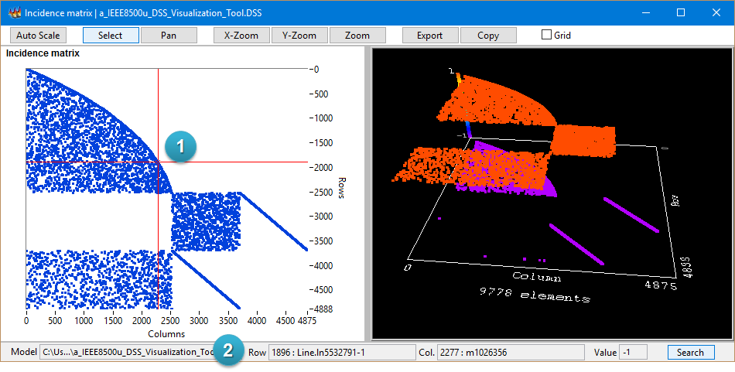

Figure ‑  
Cursor navigation mode on admittance matrix interface.

Pan (General tools)

This function enables the panning tool. The user can use this tool to navigate by means of click and dragging the content of the plot area.

X-Zoom (General tools)

This function enables the horizontal zooming tool. The user can use this tool to navigate by means of click and holding to delimitate the area of interest.

Y-Zoom (General tools)

This function enables the vertical zooming tool. The user can use this tool to navigate by means of click and holding to delimitate the area of interest.

Zoom (General tools)

This function enables the rectangular zooming tool. The user can use this tool to navigate by means of click and holding to delimitate the area of interest.

Export (General tools)

This button triggers a dialog window with export options as shown in Figure 4‑13. The dialog allows the user to enable/disable the grid, generate graphics output files (BMP, EPS, EMF), exporting the data to a new Excel file, or saving the matrix on the matrix market format. Multiple options can be selected on this dialog. Microsoft Excel is required to export the data to an Excel file.

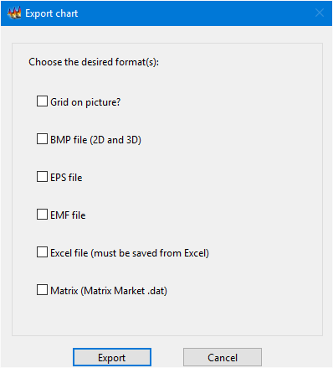

Figure ‑  
Export dialog for admittance matrix interface.

Copy (General tools)

This button triggers a dialog window with copy options as shown in Figure 4‑14. The dialog allows the user to enable/disable the grid, and copy graphics output files of the two-dimensional view (BMP, EPS, EMF) to the clipboard. Only one file format can be selected on this dialog.

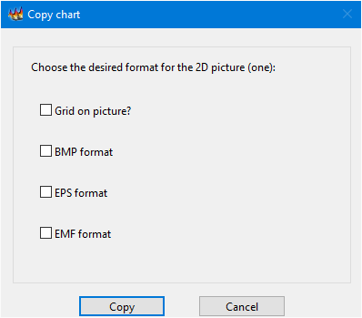

Figure ‑  
Copy dialog for admittance matrix interface.

Grid (General tools)

This option can be used to enable/disable the grid on the two-dimensional plot area.

Search (Auxiliary bar)

This button triggers a dialog window with search tools as shown in Figure 4‑15 and Figure 4‑16. As can be seen in Figure 4‑15, the search dialog shows the chart name (highlighted with the number 1), and it also allows the user to search for a row or column name by means of the string controls highlighted with the numbers 2 and 3, respectively. The row names list, highlighted with the number 4, is auto-populated with the full list of row names or the closest match for the desired search. Similarly, the column names list, highlighted with the number 5, is auto-populated with the full list of column names or the closest match for the desired search. Both label lists are enabled for cross filtering. In this way, selecting one element filters the coincidences on the complementary list based on the matrix content. For instance, if the user selects a power delivery element (row name) on an incidence matrix plot, this function filters the names of the buses attached to the corresponding element (column names). The function of the button highlighted with the number 6 is exemplified in the next figure. Finally, the button highlighted with the number 7 can be used to clear the search and remove the cursor from the matrix plot interface.

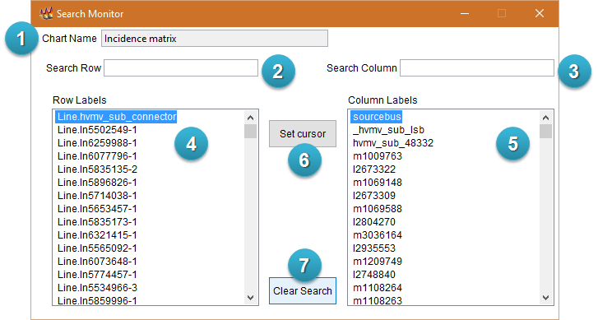

Figure ‑  
Search dialog on matrix plot interface.

As can be seen in Figure 4‑16, after selecting a row and column label, the button highlighted by the number 1 updates the cursor location on the two-dimensional view of the plot interface (the cursor location is highlighted with the number 2).

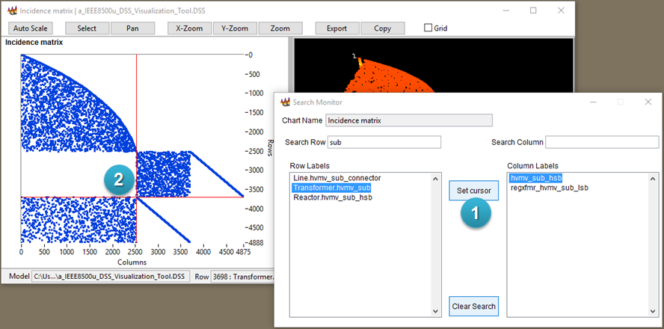

Figure ‑  
Example for set cursor function on matrix plot.

3D Navigation

The three-dimensional plot can be navigated by clicking inside the 3D Graph container and using the mouse to change the view. To rotate the graph, click and drag the mouse across the graph container. To pan across the graph, press and hold the control key, then click and drag the mouse. To zoom in or out on the graph, press and hold the shift key, then click and drag the mouse.

Scatter Plot

The scatter plot was designed to plot and navigate in the two-dimensional and three-dimensional representations of electrical variables with geographical references. This interface can be used to analyze a snapshot of simulation results with color ramps associated to electrical values at each bus. The user interface is composed of seven areas, as shown in Figure 4‑17.

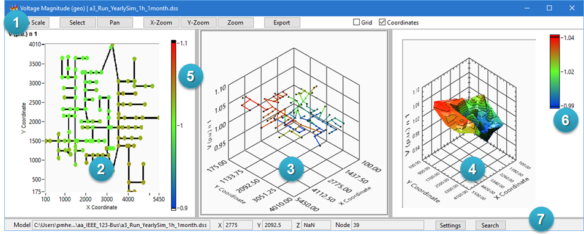

Figure ‑  
Scatter plot interface.

Interface components

The main components of the user interface are described below. Numbers inside parenthesis refer to circled numbers on Figure 4‑17.

|  |  |
| --- | --- |
| General Tools (1) | This area has buttons to trigger interface functions or provide quick customization to the figure. Please refer to the Interface Functions section for additional information. |
| 2D Plot area (2) | This area shows the two-dimensional representation of the data in Cartesian coordinates. Each dot represents a bus location with defined coordinates in the model. The associated color can be interpreted as a representation of the electrical variable magnitude by means of the two-dimensional color ramp (5). Please consult the window title and figure name to get information about the plotted electrical variable. Black lines in this area represent power delivery devices (lines, transformers, etc.) connected between two geo-referenced buses. The axes limits can be customized by double-clicking the numbers on the limit to introduce a new numerical value. |
| 3D Scatter plot area (3) | This area shows the three-dimensional representation of the data in Cartesian coordinates. The X and Y axes are associated with the X and Y coordinates on the circuit model. The Z axis is associated with the magnitude of the desired electrical variable (please consult the window title and figure name to get information about the plotted electrical variable). Each dot represents a bus location with defined coordinates in the model. Color lines in this area represent power delivery devices (lines, transformers, etc.) connected between two geo-referenced buses. The associated color can be interpreted by means of the three-dimensional color ramp (6). Further customization options (colors, cursors, axis limits, etc.) can be found by right-clicking on the figure and selecting the 3D Graph Properties option. Users are encouraged to explore the multiple options on this customization menu. Please refer to the 3D navigation section for further information about zooming and panning. |
| 3D Surface plot area (4) | This area shows the three-dimensional representation of the data in Cartesian coordinates. The X and Y axes are associated with the X and Y coordinates on the circuit model. The Z axis is associated with the magnitude of the desired electrical variable (please consult the window title and figure name to get information about the plotted electrical variable). The surface results from a linear geometric interpolation between the electrical variable magnitudes on the geo-referenced buses. The associated color can be interpreted by means of the three-dimensional color ramp (6). Further customization options (colors, cursors, axis limits, etc.) can be found by right-clicking on the figure and selecting the 3D Graph Properties option. Users are encouraged to explore the multiple options on this customization menu. Please refer to the 3D navigation section for further information about zooming and panning. |
| Two-dimensional color ramp (5) | This color ramp represents the electrical variable magnitude with three colors interpolated between a minimum and maximum numerical limit. Please consult the window title and figure name to get information about the plotted electrical variable. This color ramp and the vertical axis limit on (3) and (4) can be customized by double-clicking the numbers on the limit to introduce a new numerical value. |
| Three-dimensional color ramp (6) | This color ramp represents the electrical variable magnitude with three colors interpolated between the minimum and maximum values of the plotted data. Please consult the window title and figure name to get information about the plotted electrical variable. |
| Auxiliary bar (7) | This area shows complementary information and additional customization functions.   * Model: Directory path to the DSS file used to generate the figure. * X: Current coordinate of the horizontal axis at the cursor location. This value is dynamically updated when the cursor location changes. * Y: Current coordinate of the vertical axis at the cursor location. This value is dynamically updated when the cursor location changes. * Node: Node name at the cursor location. This value is dynamically updated when the cursor location changes. |

Interface Functions

The following are descriptions of each function on the user interface.

Auto Scale (General tools)

This button triggers an automatic adjustment of the axes on the figures. It is useful to restore the initial appearance of the figure after zooming or navigating.

Select (General tools)

This button enables the cursor navigation mode shown in Figure 4‑18. The cursor is shown as a red mark with horizontal and vertical projections on the two-dimensional view. As can be seen in Figure 4‑18, the current cursor location is highlighted with the number 1, and the cursor coordinates are highlighted with the number 2. The user can drag the cursor location with a click and hold on the central point of the cursor. It is also possible to move the cursor location by dragging the horizontal or vertical projections lines (red lines). The three-dimensional plots cursors are dynamically updated from the current coordinates on the two-dimensional view (they are highlighted with the numbers 3 and 4). However, the interface is designed for cursor navigation from the two-dimensional view only.

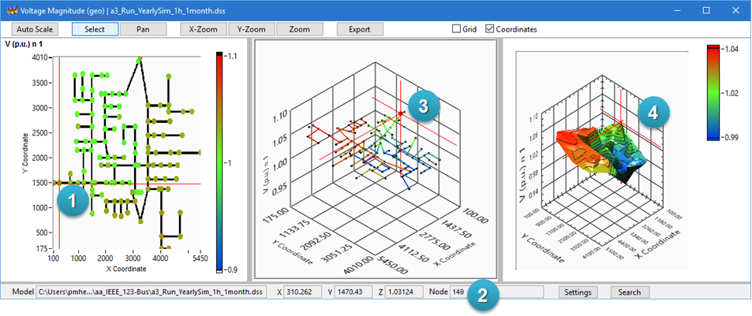

Figure ‑  
Cursor navigation mode on scatter plot.

Pan (General tools)

This function enables the panning tool on the two-dimensional view. The user can use this tool to navigate by means of click and dragging the content of the plot area.

X-Zoom (General tools)

This function enables the horizontal zooming tool on the two-dimensional view. The user can use this tool to navigate by means of click and holding to delimitate the area of interest.

Y-Zoom (General tools)

This function enables the vertical zooming tool on the two-dimensional view. The user can use this tool to navigate by means of click and holding to delimitate the area of interest.

Zoom (General tools)

This function enables the rectangular zooming tool on the two-dimensional view. The user can use this tool to navigate by means of click and holding to delimitate the area of interest.

Export (General tools)

This button triggers a dialog window with export options as shown in Figure 4‑19. The dialog allows the user to enable/disable the grid, generate graphics output files (BMP, JPEG, PNG), or exporting the data to a new Excel file. Multiple options can be selected on this dialog. Microsoft Excel is required to export the data to an Excel file.

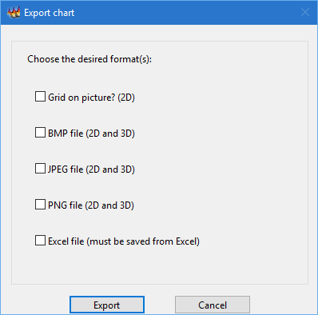

Figure ‑  
The export dialog of the scatter plot interface.

Grid (General tools)

This option can be used to enable/disable the grid on the two-dimensional plot area.

Coordinates (General tools)

This option can be used to enable/disable the X and Y coordinate marks on the plot areas.

Settings (Auxiliary bar)

This button triggers a dialog window with settings options as shown in Figure 4‑20 and Figure 4‑21. As can be seen in Figure 4‑20, the data dialog shows the chart name (highlighted with the number 1), and it also allows the user to choose between multiple sets of data to plot (highlighted with the number 2). After selecting the desired data, the update button highlighted by the number 3 generates a fresh version of the plots in the interface.

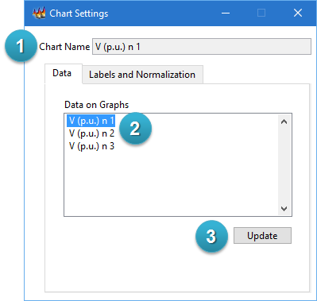

Figure ‑  
Chart settings dialog for scatter plot interface (Data).

As can be seen in Figure 4‑21 the labels and normalization dialog includes two areas for axes customization. The X and Y axes labels can be adjusted with the numeric controls highlighted with the number 2. The variable magnitude base value and color ramp labels can be adjusted with the controls highlighted with the number 3.

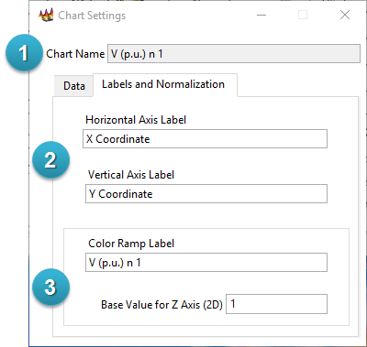

Figure ‑  
Chart settings dialog for scatter plot interface (Labels and normalization).

Search (Auxiliary bar)

This button triggers a dialog window with search tools as shown in Figure 4‑22 and Figure 4‑23. As can be seen in Figure 4‑22, the data dialog shows the chart name (highlighted with the number 1), and it also allows the user to search for a bus name by means of the string control highlighted with the number 2. The bus names list, highlighted with the number 3, is auto-populated with the full list of bus names or the closest match for the desired search. After selecting the desired bus, the button highlighted by the number 4 updates the name, coordinates, and variable magnitude on the area highlighted with the number 7. The function of the button highlighted with the number 5 is exemplified in the next figure. Finally, the button highlighted with the number 6 can be used to delete the cursor from the scatter plot interface.

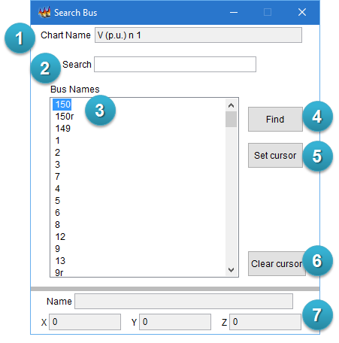

Figure ‑  
Search dialog on scatter plot interface.

As can be seen in Figure 4‑23, after selecting the desired bus, the button highlighted by the number 1 updates the cursor label and location on the plotting areas of the scatter plot interface (the cursor location is highlighted with the numbers 2, 3, and 4).

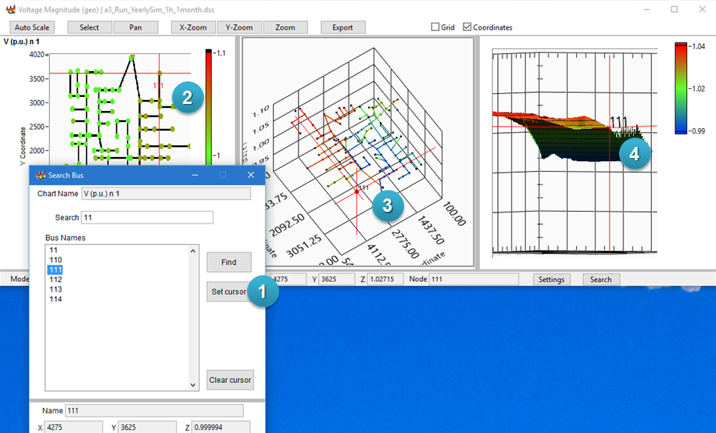

Figure ‑  
Example for set cursor function on scatter plot.

3D Navigation

The three-dimensional plot can be navigated by clicking inside the 3D Graph container and using the mouse to change the view. To rotate the graph, click and drag the mouse across the graph container. To pan across the graph, press and hold the control key, then click and drag the mouse. To zoom in or out on the graph, press and hold the shift key, then click and drag the mouse. To obtain the three-dimensional plot in an independent window, right click on the 3D Graph container and select the render window option.

Density Evolution Plot

The density evolution interface was designed to plot and navigate in the two-dimensional and three-dimensional representations of statistical variables obtained from electrical variables in time-sequential simulations. This interface can be used to analyze large amounts of data by means of statistical inference and non-parametric function estimations.

Data and figures for this visualization were obtained based on the method proposed by "Miguel Hernandez, Gustavo Ramos, Harsha V. Padullaparti, and Surya Santoso" [1] [2]. Please read and include the following references in derivative works:

[1] M. Hernandez, G. Ramos, H. Padullaparti, and S. Santoso, “Statistical Inference for Visualization of Large Utility Power Distribution Systems,” Inventions, vol. 2, no. 2, p. 11, Jun. 2017.

[2] M. Hernandez, G. Ramos, H. Padullaparti, and S. Santoso, “Visualization of Time-Sequential Simulation for Large Power Distribution Systems,” 2017 IEEE Manchester PowerTech, 1–6, IEEE. doi:10.1109/PTC.2017.7981076, Jun. 2017.

The user interface is composed of five areas, as shown in Figure 4‑24.

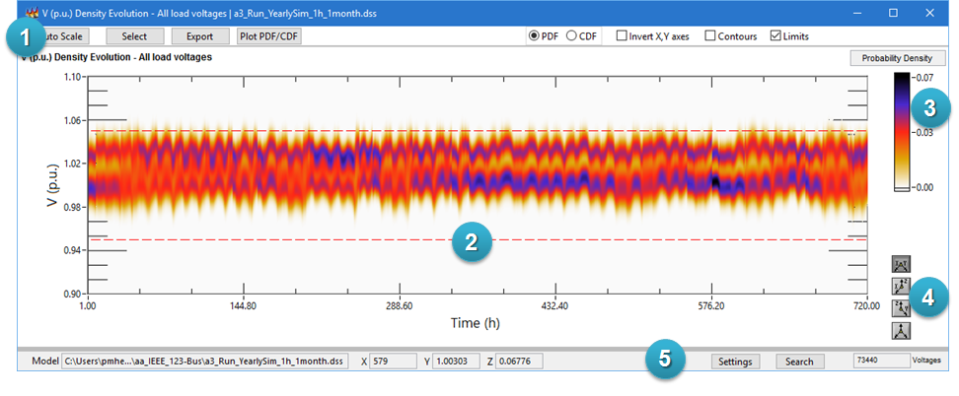

Figure ‑  
Density evolution plot interface.

Interface components

The main components of the user interface are described below. Numbers inside parenthesis refer to circled numbers on Figure 4‑24.

|  |  |
| --- | --- |
| General Tools (1) | This area has buttons to trigger interface functions or provide quick customization to the figure. Please refer to the Interface Functions section for additional information. |
| Plot area (2) | This area shows the three-dimensional or two-dimensional representation of the data in Cartesian coordinates. This data is obtained from a kernel estimation of the probability density function which describes an electrical variable in the circuit. The X-axis is associated with the time domain, the Y-axis is associated to the electrical variable, and the Z-axis is associated with the magnitude of the statistical variable (probabilistic density function - PDF or cumulative density function - CDF). The associated color can be interpreted as a representation of the statistical variable by means of the color ramp (3). Please consult the window title and figure name to get information about the plotted variable. Dark colors in this area represent high probabilistic density or high cumulative probability according to the plotted data (please refer to PDF and CDF interface functions in the following section). The axes limits can be customized by double-clicking the numbers on the limit to introduce a new numerical value when the two-dimensional view is activated. Further customization options (colors, cursors, axis limits, etc.) can be found by right-clicking on the figure and selecting the 3D Graph Properties option. Users are encouraged to explore the multiple options on this customization menu. Please refer to the 3D navigation section for further information about zooming and panning. |
| Color ramp (3) | This color ramp represents the statistical variable magnitude with three colors interpolated between the minimum and maximum values of the plotted data. Please consult the window title and figure name to get information about the plotted variable. |
| Projection palette (4) | This tool can be used to customize the plane projection view. The projection palette contains the following buttons:   * X-Y plane projection: Displays the plot projection on the X-Y plane. This is a two-dimensional representation of the data. * X-Z plane projection: Displays the plot projection on the X-Z plane. This is a two-dimensional representation of the data. * Y-Z plane projection: Displays the plot projection on the Y-Z plane. This is a two-dimensional representation of the data. * 3D projection: Displays the plot on the 3D plane. This is a three-dimensional representation of the data. |
| Auxiliary bar (5) | This area shows complementary information and additional customization functions.   * Model: Directory path to the DSS file used to generate the figure. * X: Current value of the X-axis at the cursor location. This value is dynamically updated when the cursor location changes. * Y: Current value of the Y axis at the cursor location. This value is dynamically updated when the cursor location changes. * Z: Current value of the PDF or CDF value at the cursor location. Please refer to PDF and CDF interface functions in the following section. This value is dynamically updated when the cursor location changes. * Voltages: Total count of voltages provided from the simulation to obtain the current visualization. This is an indicator of the amount of data contained in this statistical analysis. |

Interface Functions

The following are descriptions of each function on the user interface.

Auto Scale (General tools)

This button triggers an automatic adjustment of the axes on the figures. It is useful to restore the initial appearance of the figure after zooming or navigating.

Select (General tools)

This button enables the cursor navigation mode shown in Figure 4‑25. The cursor is shown as a red mark with X and Y projections and an associated plane on the X-Y reference frame. Further customizations can be found by right-clicking on the figure and selecting the 3D Graph Properties option. As can be seen in Figure 4‑25, the current cursor location is highlighted with the number 1, and the cursor coordinates are highlighted with the number 2. The user can drag the cursor location with a click and hold on the central point of the cursor.

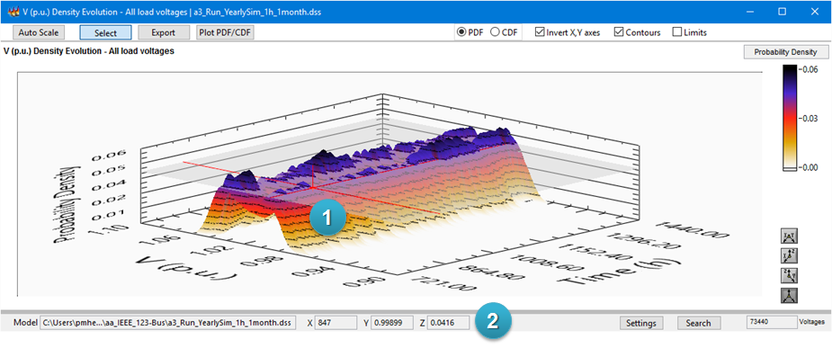

Figure ‑  
Cursor navigation mode on density evolution plot.

Export (General tools)

This button triggers a dialog window with export options as shown in Figure 4‑26. The dialog allows the user to generate graphics output files (BMP, JPEG, PNG) and exporting the data to a comma-separated-values file (CSV). Multiple options can be selected on this dialog.

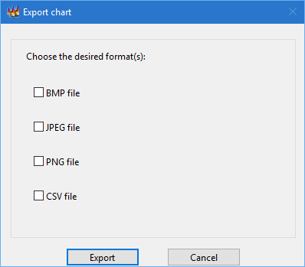

Figure ‑  
Export dialog for density evolution interface.

Plot PDF/CDF (General tools)

This button (highlighted by the number 1) generates two X-Y plots with the two-dimensional representation of the probabilistic density function and cumulative density function at the time step selected by the cursor location (highlighted by the number 2), as shown in Figure 4‑27. The resulting figures, highlighted by the numbers 3 and 4, are the two-dimensional representation of a cut in the Z-Y plane at the X cursor position. Please refer to the X-Y Plot figure description for further information.

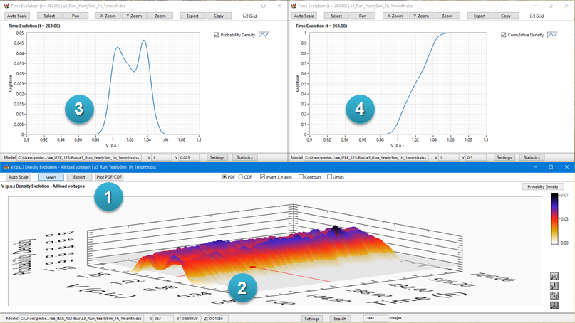

Figure ‑  
Example for plot PDF/CDF functions.

PDF (General tools)

This option can be used to update the content of the figure to depict the probability density function estimation (Figure 4‑28). The Z-axis values and color ramp are associated to the probability density values. Dark colors in this view represent a high amount of electrical variables associated with a certain value (Y-axis) at a certain time (X-axis). Please consult the window title and figure name to get information about the plotted variable.

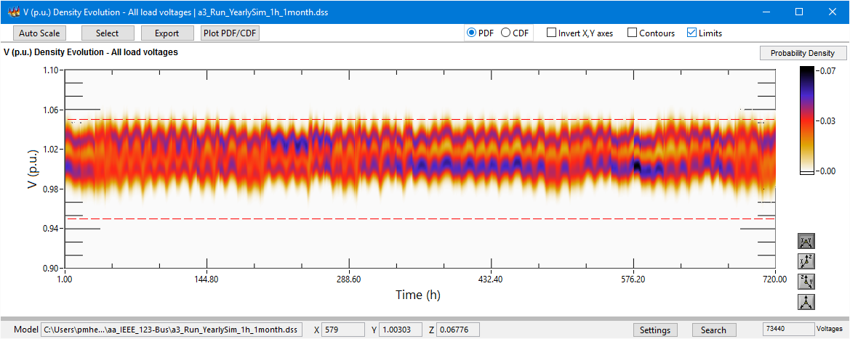

Figure ‑  
Example of the probability density function view.

CDF (General tools)

This option can be used to update the content of the figure to depict the cumulative density function estimation (Figure 4‑29). The Z-axis values and color ramp are associated to the cumulative probability values. The red color in this view represents that 50% of the total amount of electrical variables are exhibiting values between cero and certain value (Y-axis) at a certain time (X-axis). Please consult the window title and figure name to get information about the plotted variable.

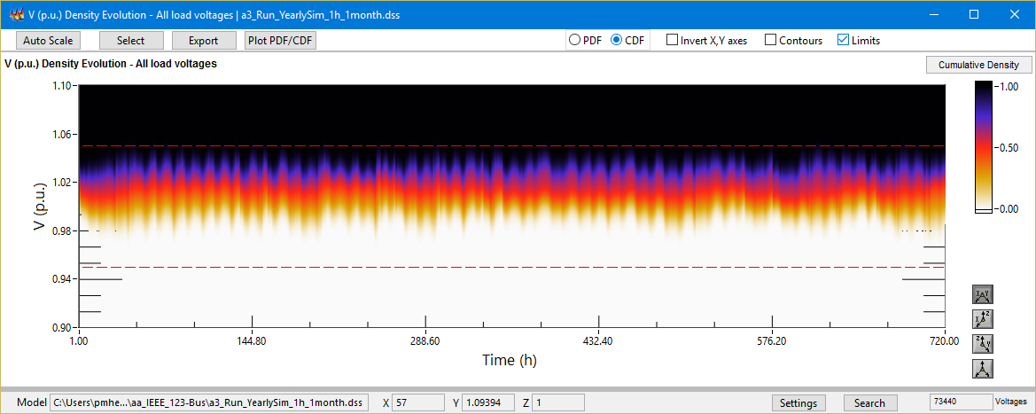

Figure ‑  
Example of the cumulative density function view.

Invert X, Y axes (General tools)

This option can be used to invert the X and Y axes range in the plot area. This feature provides a convenient navigation in the space between the two-dimensional and three-dimensional views.

Contours (General tools)

This option can be used to enable/disable the contour lines on the plot area.

Limits (General tools)

This option can be used to enable/disable the voltage limits represented by a couple of X-Z planes (0.95 Vpu and 1.05 Vpu by default). The voltage limits can be customized from the 3D Graph Properties option as described in the interface components section.

Settings (Auxiliary bar)

This button triggers a dialog window with settings options as shown in Figure 4‑30. The data dialog shows the chart name (highlighted with the number 1), and it also allows the user to customize the labels and base values for the X axis (highlighted with the number 2), Y-axis (highlighted with the number 3), and Z axis (highlighted with the number 4). The adjustment of base values can be used to obtain *per unit* values on the Y-axis, to change the time scale of the figure (changes between seconds, minutes, days, etc.), or to scale the values of statistical data (probability to percentage).

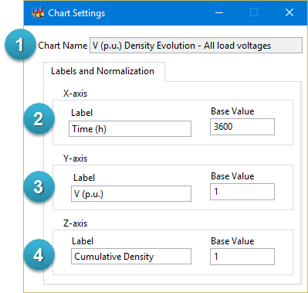

Figure ‑  
Settings dialog for density evolution interface.

Search (Auxiliary bar)

This button triggers a dialog window with search tools as shown in Figure 4‑31. The data dialog shows the chart name (highlighted with the number 1), and it also allows the user to search for a monitor name by means of the string control highlighted with the number 2. The time step of interest can be selected by means of the number control highlighted by the number 3. The bus names list, highlighted with the number 4, is auto-populated with the full list of monitor names or the closest match for the desired search. After selecting the desired monitor, the find button in the area highlighted by the number 6 updates the name, coordinates, and variable magnitude on the area highlighted with the number 8. After selecting the desired monitor, the set cursor button in the area highlighted by the number 6 updates the cursor label and location on the plotting area (the cursor location is highlighted with the number 9). The function of the plot areas highlighted by buttons 5 and 7 is exemplified in the next figure. Finally, the button clear cursor in the area highlighted by the number 6 can be used to delete the cursor from the plot interface.

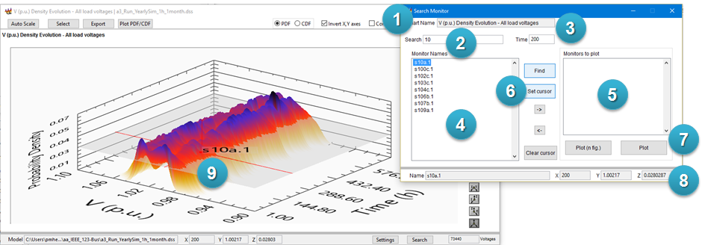

Figure ‑  
Search dialog on density evolution plot.

The search dialog includes a feature to generate independent plots of the electrical variables used for estimating the density evolution. As can be seen in Figure 4‑32, the area highlighted with the number 1 contains a list of monitors that can be chosen from the list of monitor names at the right. Monitors can be aggregated or eliminated from the list highlighted with the number 1 by means of the arrow buttons in the middle. When the list of monitors to plot is ready, the user can click on the plot button highlighted by the number 2 to generate an X-Y plot with all the desired monitors. It is also possible to generate individual plots for each desired monitor by means of the button denominated plot (n fig.).

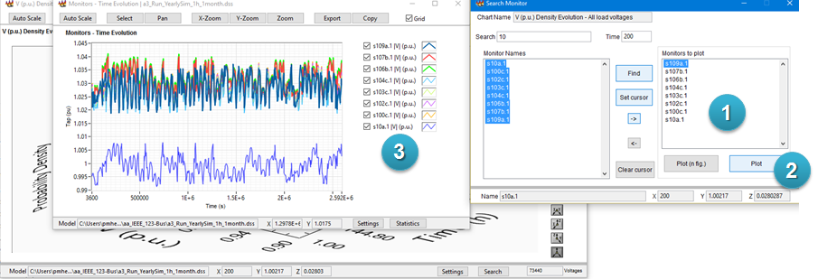

Figure ‑  
Example of plotted monitors from density evolution interface.

3D Navigation

The three-dimensional plot can be navigated by clicking inside the 3D Graph container and using the mouse to change the view. To rotate the graph, click and drag the mouse across the graph container. To pan across the graph, press and hold the control key, then click and drag the mouse. To zoom in or out on the graph, press and hold the shift key, then click and drag the mouse. To obtain the three-dimensional plot in an independent window, right click on the 3D Graph container and select the render window option.

# Communication Protocol

The DSS Visualization Tool has been implemented based on the TCP/IP protocol as an always-listening server on the port identified with the number 47625. Clients can send data content to be plotted by means of a pair of sequential packets:

1. First packet: Four bytes to describe the length (in bytes) of the payload.
2. Second packet: this is the payload of message content.

The message content is formatted as a JavaScript Object Notation (JSON) string with the following fields:

|  |  |
| --- | --- |
| Model | Type: String.  Description: Path to the file in which the current model resides. |
| Name | Type: String.  Description: Name of the plot. |
| Plot Type | Type: String.  Description: The desired figure for the current plot command.  Cases:   * “xyplot”: generates a new X-Y plot. * “profile”: generates a new voltage profile. * “matrix”: generates a new matrix plot. * “geo_scatter”: generates a new scatter plot. * “time_evolution”: generates a new density evolution plot. |
| X Axis Label | Type: String.  Description: Label of x-axis on two and three-dimensional plots. |
| X-Axis | Type: Array of doubles (2d).  Description: X-axis data to be plotted. Each row contains an independent line. |
| Plot name | Type: String array (1d).  Description: Labels for each row on Y-axis data. |
| Y-Axis | Type: Array of doubles (2d).  Description: Y-axis data to be plotted. Each row contains an independent line. |
| Phase | Type: Array of integers (1d).  Description: Auxiliary field to communicate the phase index for each row on the Y-axis data. |
| Z-Axis | Type: Array of doubles (2d).  Description: Z-axis data to be plotted. |
| PD Elements | Type: Array of strings (2d).  Description: Auxiliary field to communicate information of power delivery elements. Each row should contain the name of the element, the bus on terminal 1 and the bus on terminal 2. |
| Bus names | Type: Array of strings (1d).  Description: Auxiliary field to communicate the name of each bus on the plot. |

# Document Version History

|  |  |  |
| --- | --- | --- |
| Version 1.0 | November 2, 2017 | Initial software release and documentation.  Development: Miguel E. Hernandez F. in cooperation with “Universidad de los Andes”, Bogotá, Colombia. |

# References

1. M. Hernandez, G. Ramos, H. Padullaparti, and S. Santoso, “Statistical Inference for Visualization of Large Utility Power Distribution Systems,” *Inventions*. Vol. 2, No. 2, p. 11 (2017).
2. M. Hernandez, G. Ramos, H. Padullaparti, and S. Santoso, “Visualization of Time-Sequential Simulation for Large Power Distribution Systems,” Paper presented at the 2017 IEEE Manchester PowerTech, Manchester, UK (June 2017).